React Redux toolkit docs

1. The usual prop drilling method to pass the state:

* We first made the Navbar components and added the prop of count there

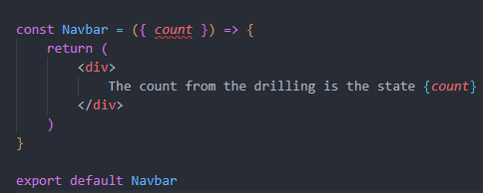

* Then in our app we added the code such as

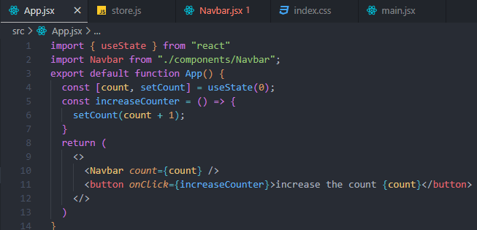

1. But this is unusual if we have tons of states. So We use react redux toolkit

* First install 
* Documentation is god so copy paste from the quick start menu of the react redux
* In the source make these files and folders

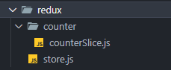

* In the main file we need to add the provider with the store

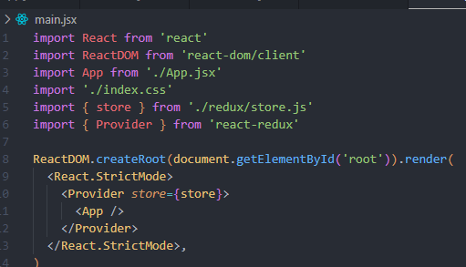

* Now in the store.js we copied from the docs
* 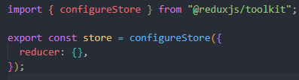
* Now in the counter slice we added the code from the docs

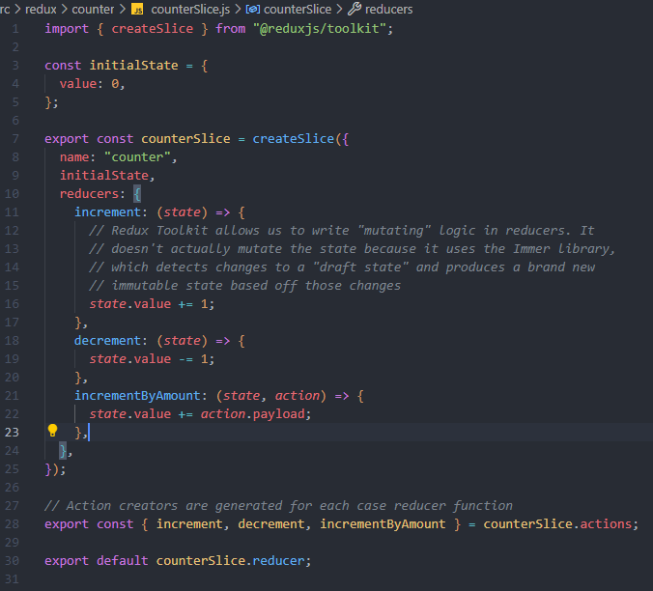

* Now we added the slide to our store like

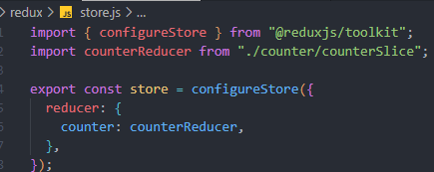

* Now everything is the game of copy paste from the docs

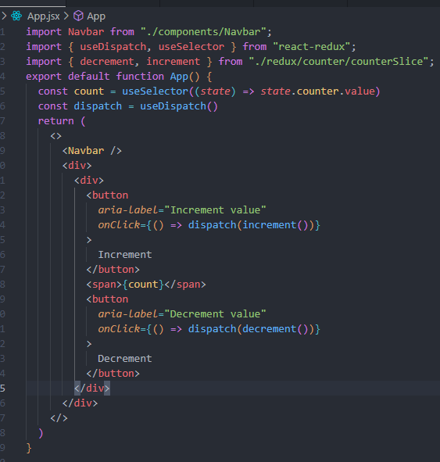

* In the Navbar now

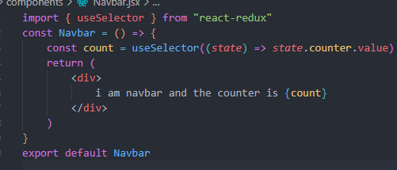

* Now everything works like a charm

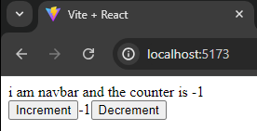

* The differences between store reducer and action

